**Pauline Erika M. Mapoy TW24 | BSIT-WMA**

**MACHINE PROBLEM - 5**

**CREATE:**

In order to assess your technical skills, this task was given to a student who is taking up the subject Advance Web Design. The output must be similar (use the video clip as your reference).

**REQUIREMENTS:**

The student must be able to produce / display:

1. Restaurant Guide
   1. In 1 (one) web page only
   2. HTML, CSS, JavaScript and Bootstrap must be used (and other programming concepts).
   3. The output must be similar to the sample video clip. All images could be replaced, fonts and colors, but the design layout and content / information must be retained. (Observe how the buttons functions: only the Main Menu allows you to close the pop-up information of the selected menu (foods) covers the entire selections).
2. Applying best practice in programming and proper folder and naming conventions. (Everything must be organized and proper, like usage of external files applying other best practices for Design and Programming must be used at all).
3. Applying everything you have learned from previous Course together with this current Course.

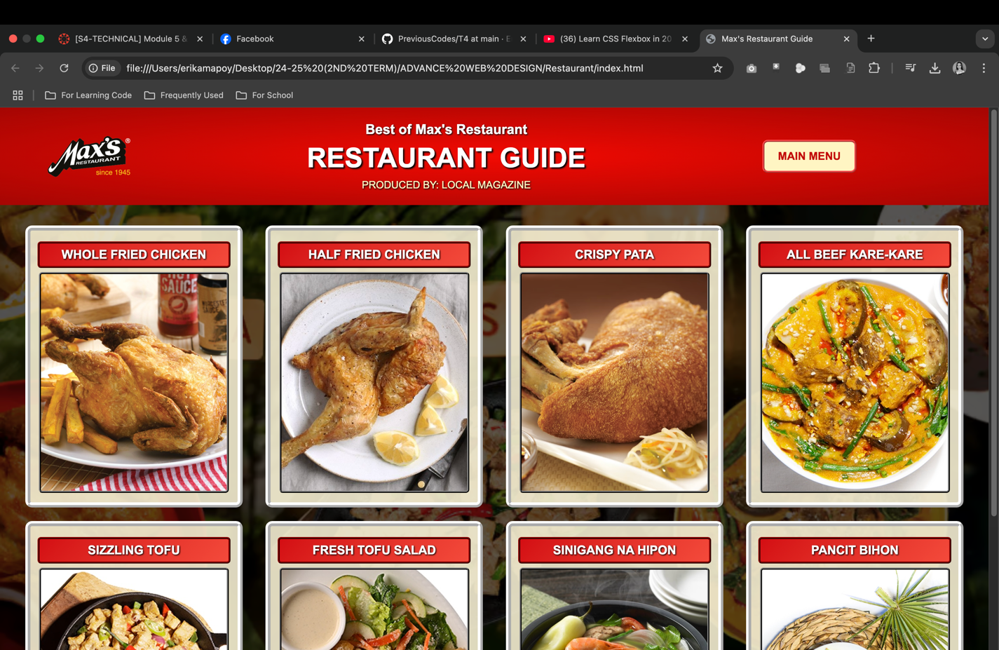

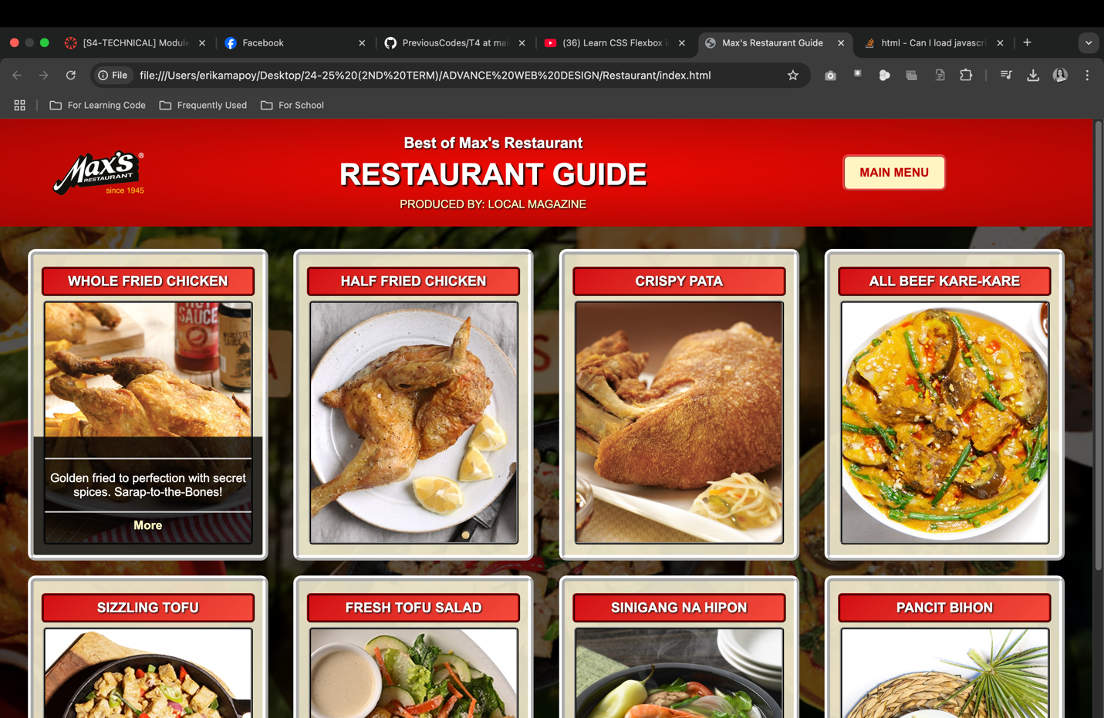

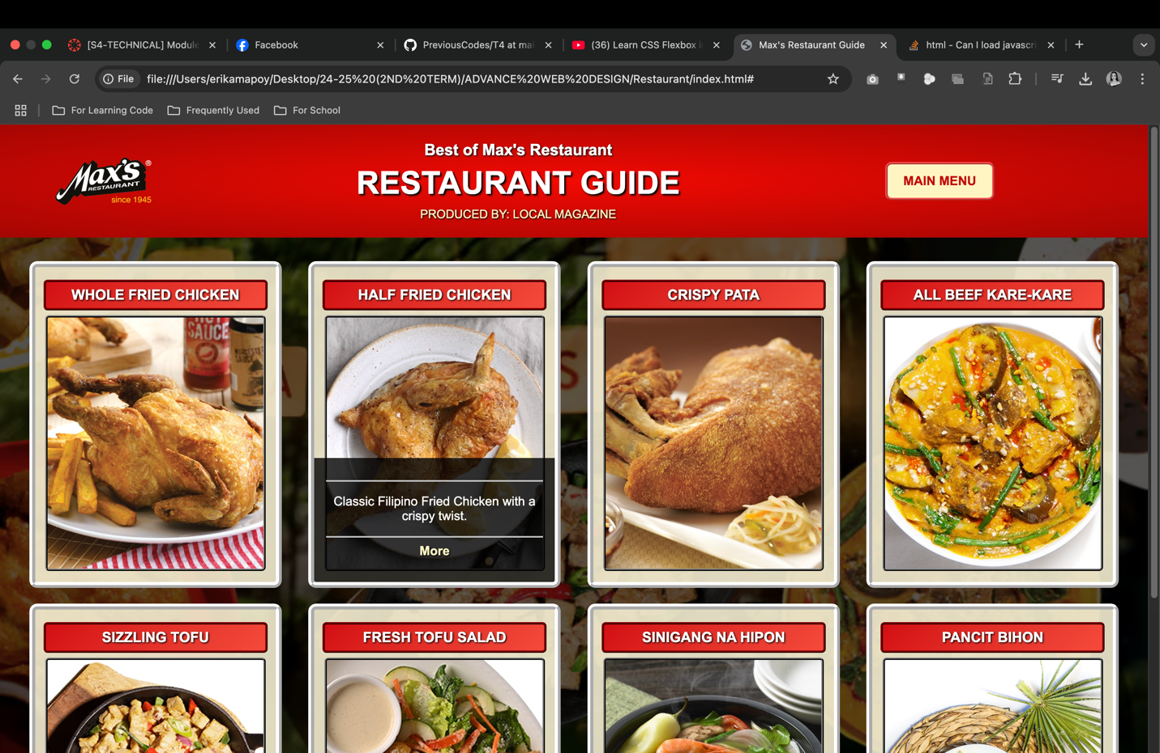

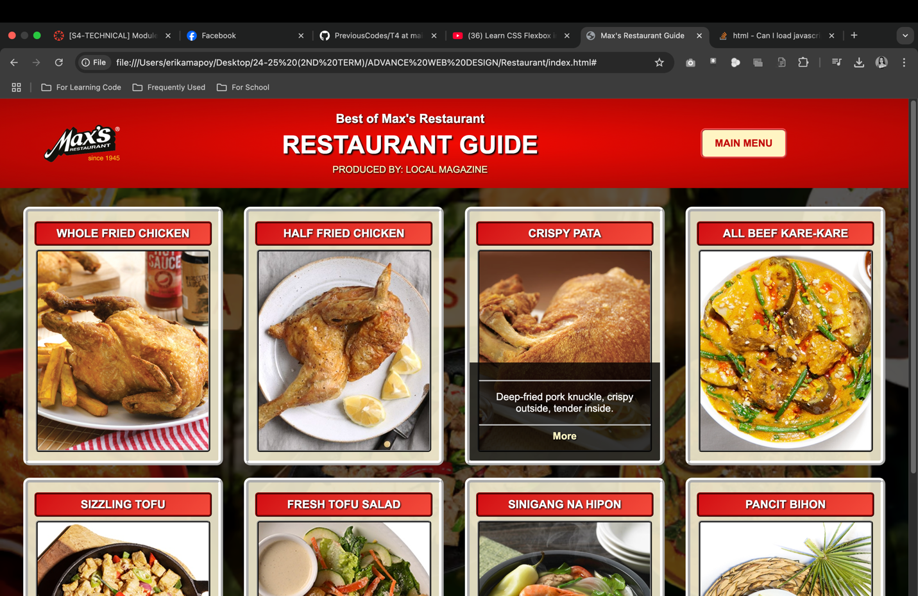

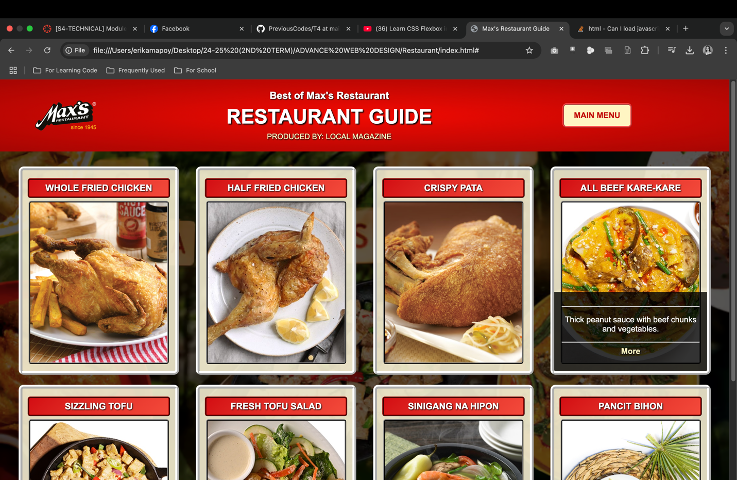

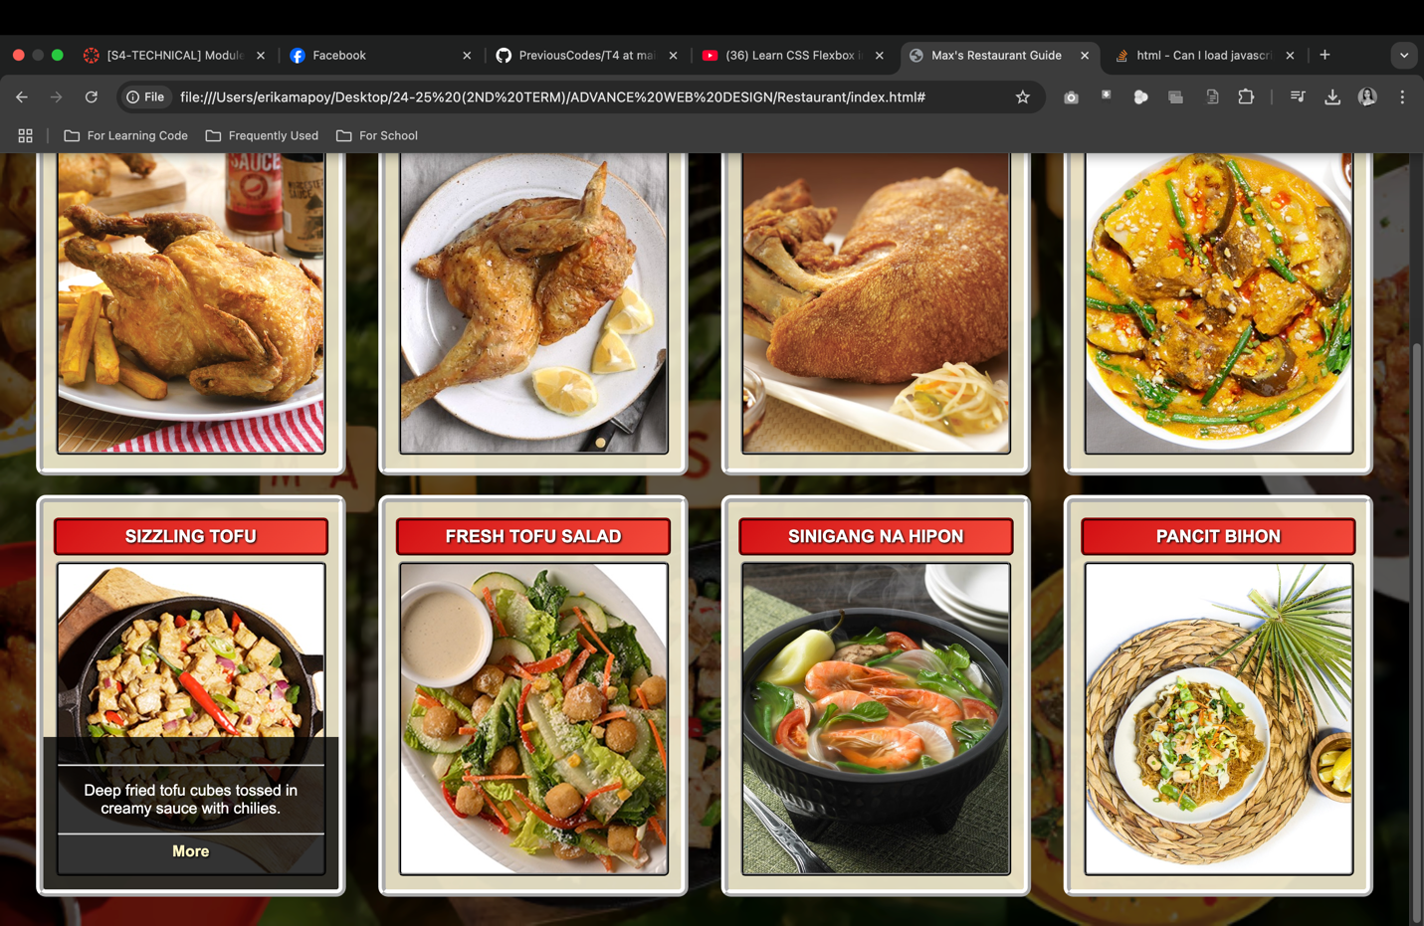

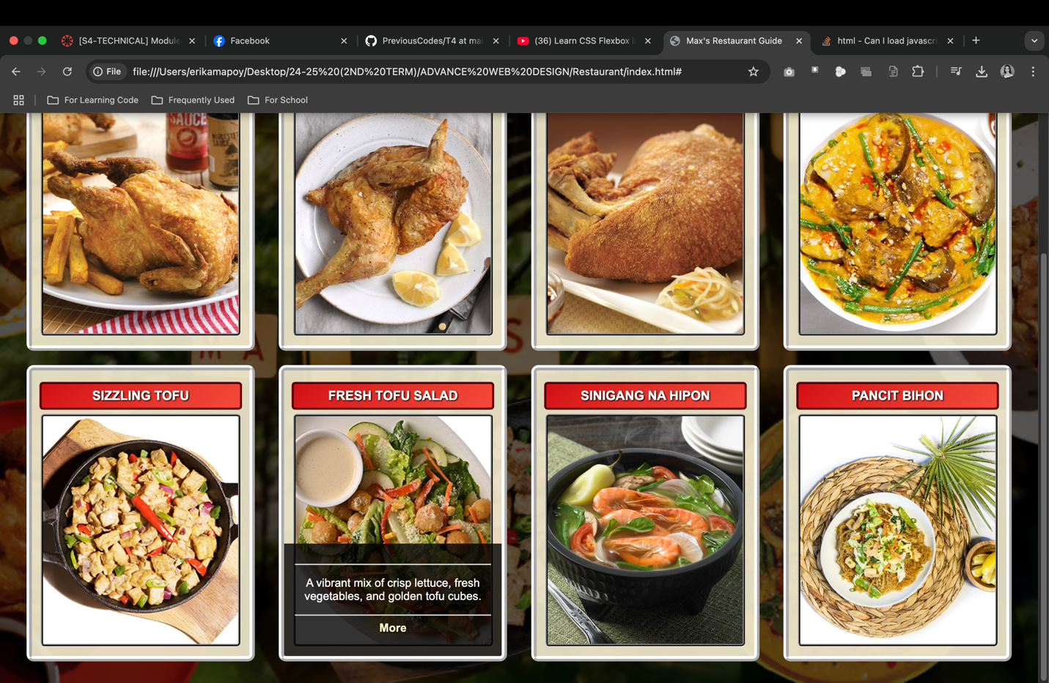

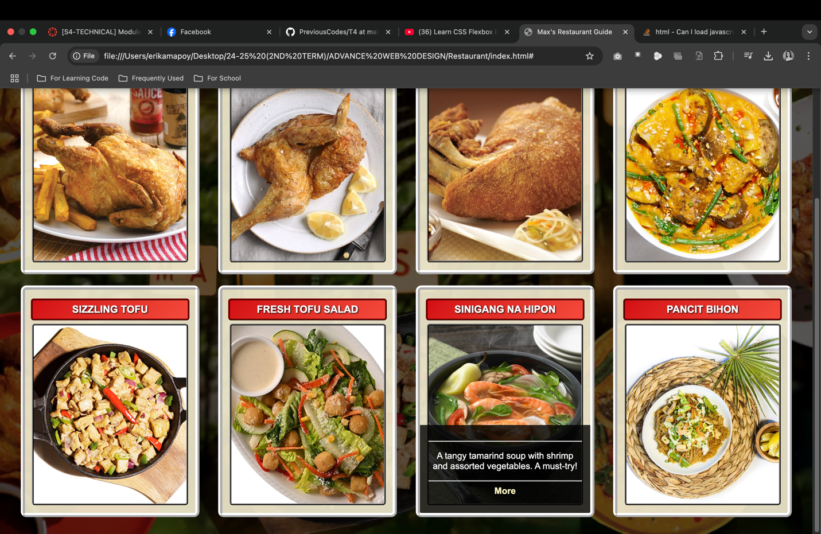

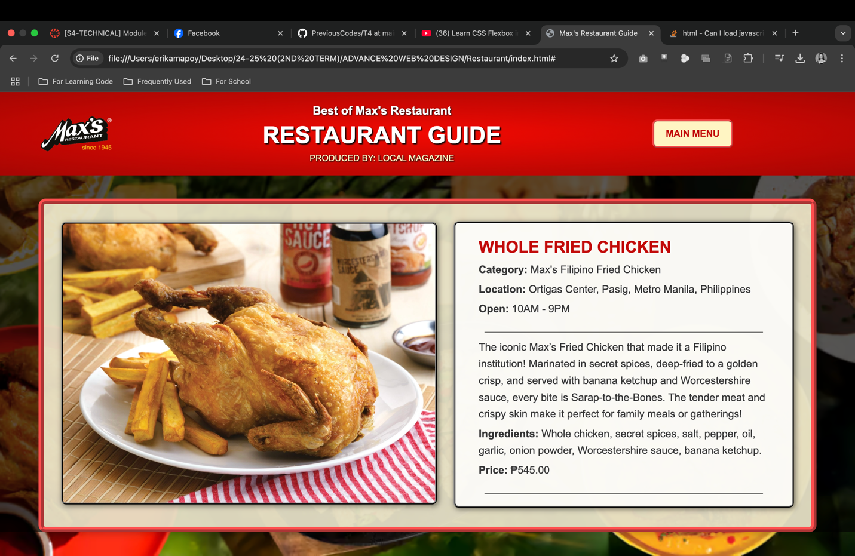

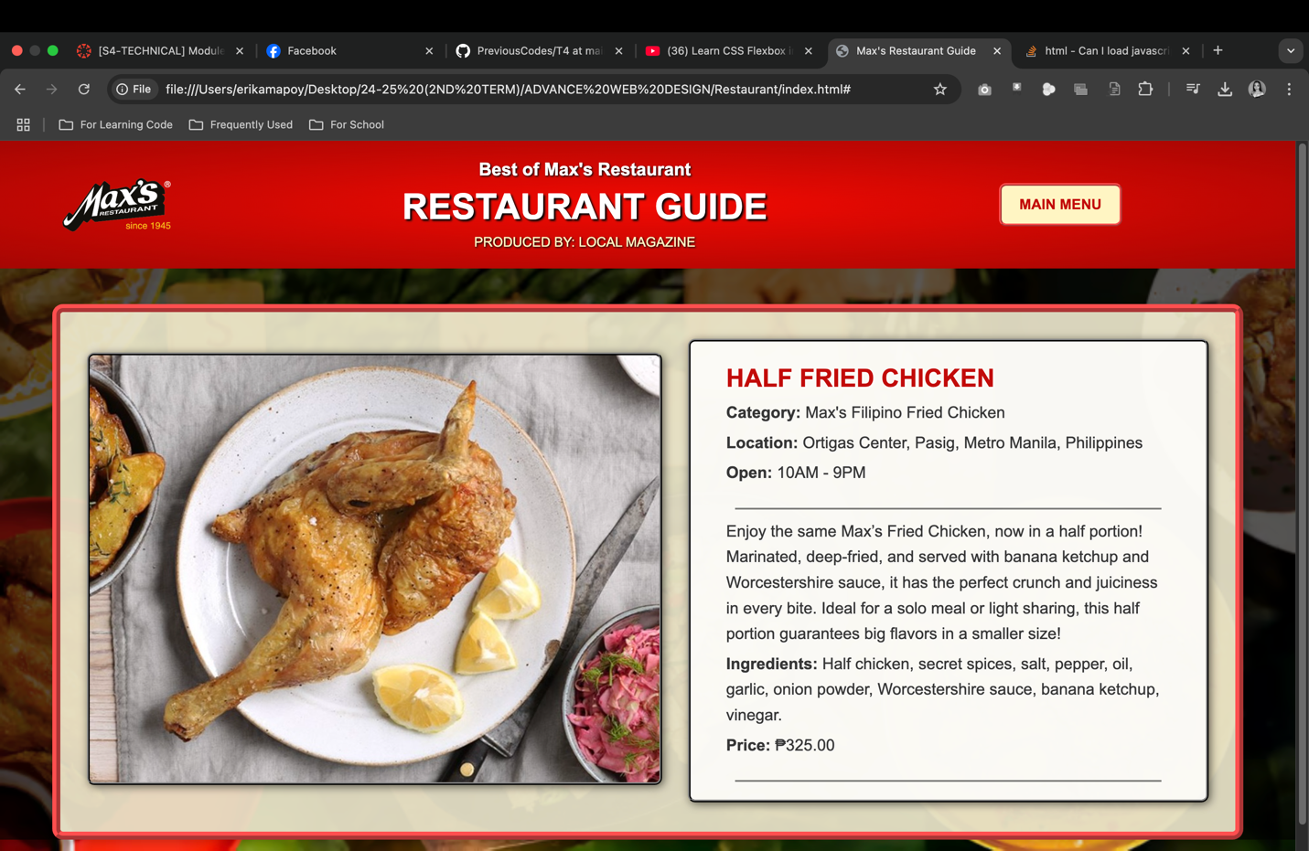

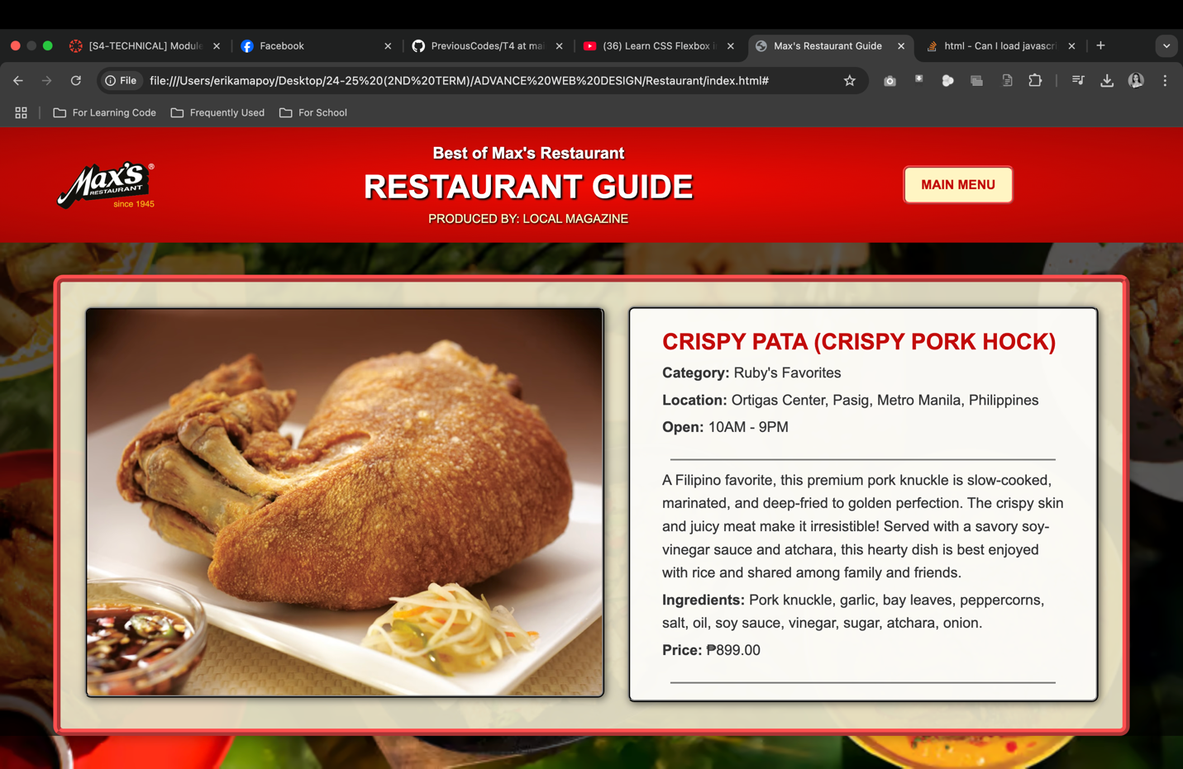

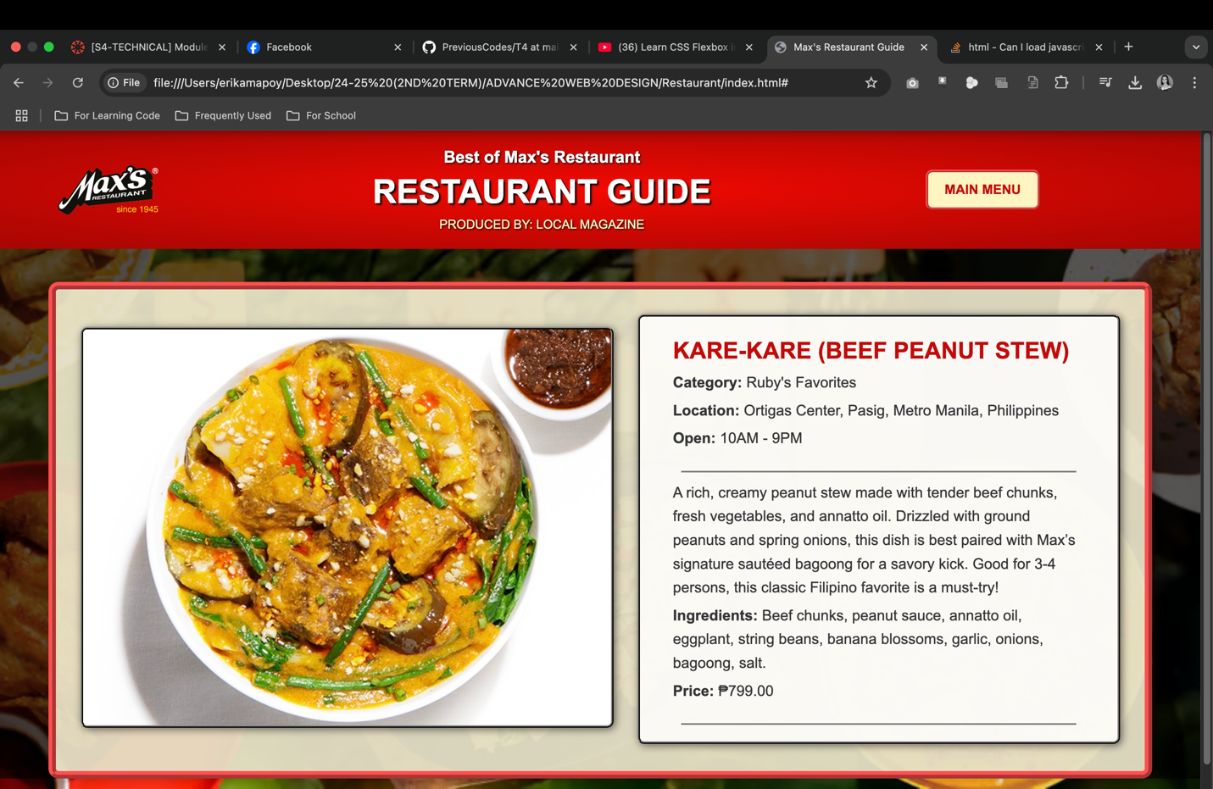

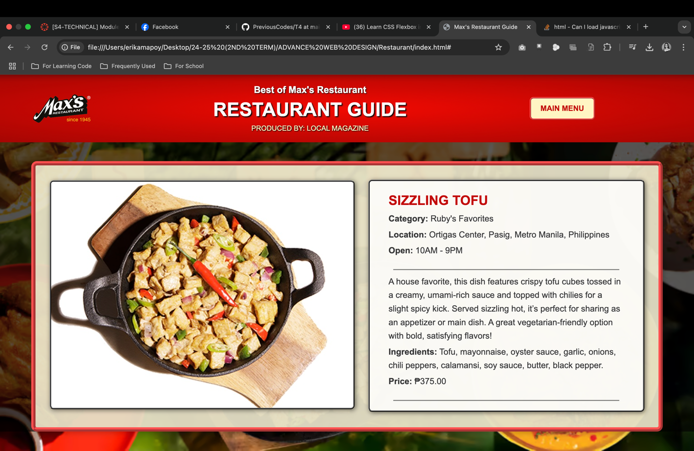

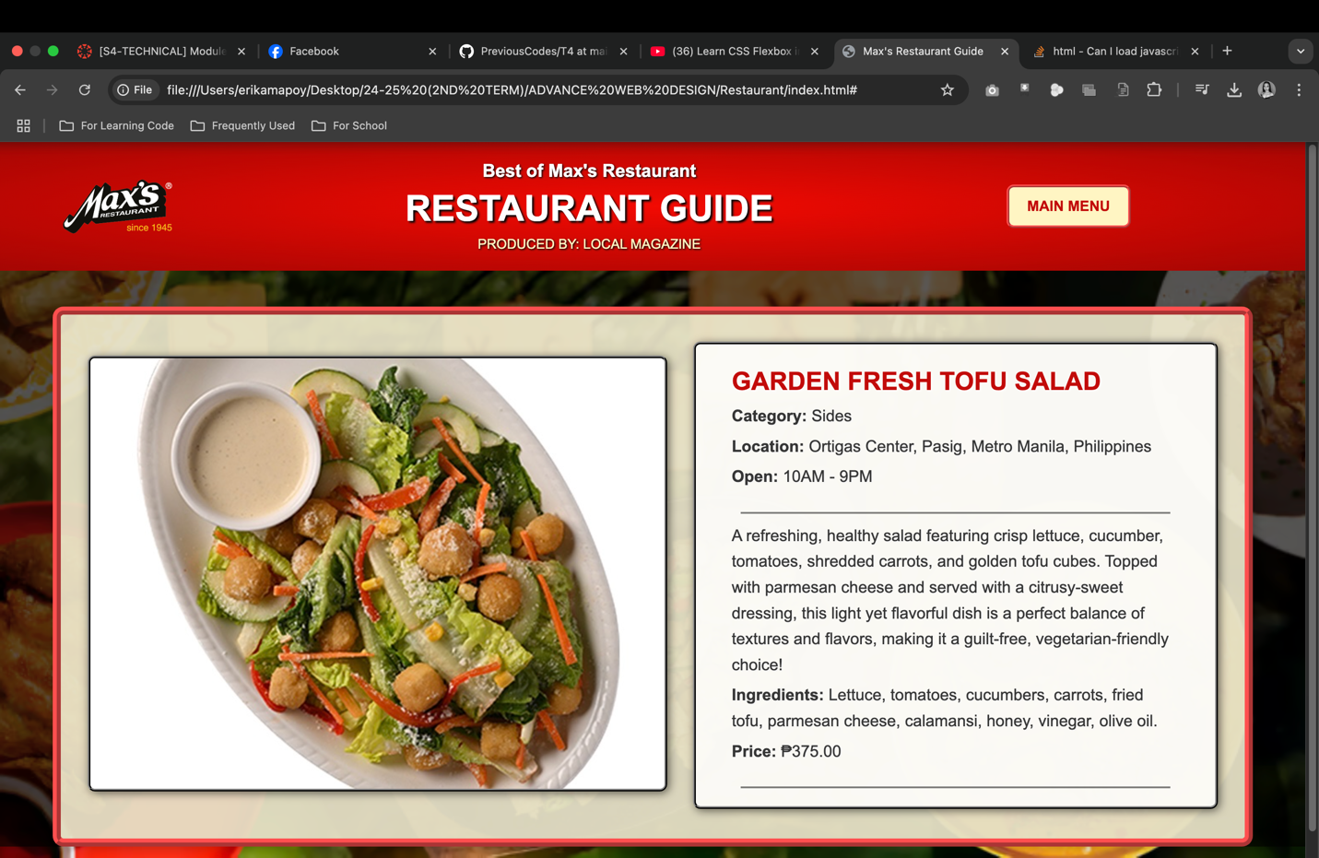

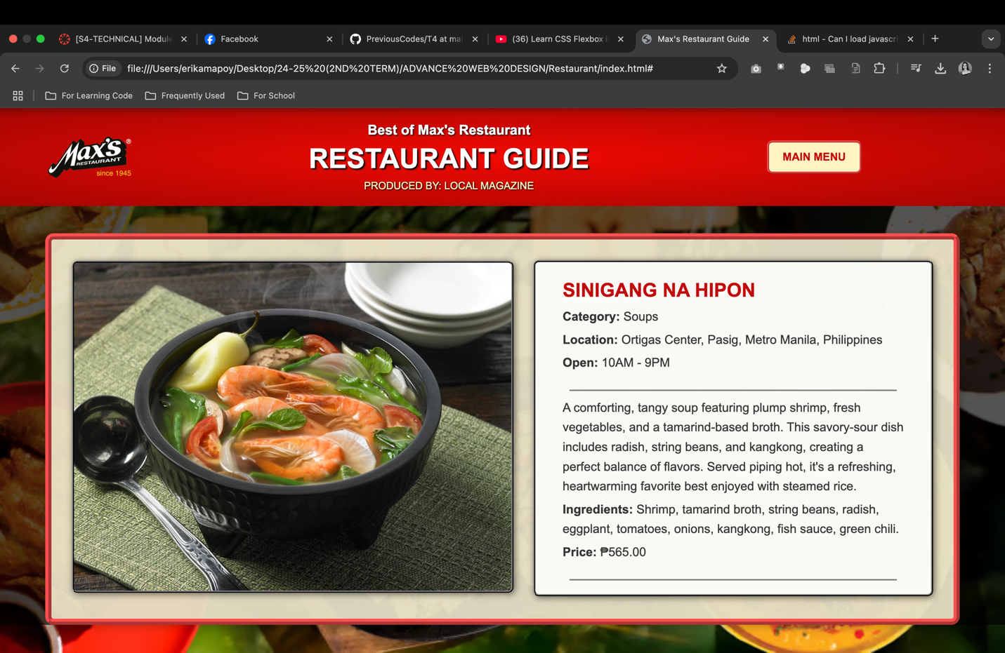

**RUBRIC**

|  |  |  |  |  |  |
| --- | --- | --- | --- | --- | --- |
| **COMPONENTS** | **5** | **4** | **3 - 2** | **1** | **TOTAL** |
| **Aesthetics** | The web site has been an exceptionally attractive and usable layout. White space, alignment are used effectively to organize material. | The web site have been attractive and usable layout. It is easy to locate all important elements. | The web site have a usable layout, but may appear busy or boring. It is easy to locate most of the important elements. | The web site are cluttered looking or confusing. It is often difficult to locate important elements. |  |
| **Content** | The web site has a well –stated clear purpose and theme that is carried out throughout the site | The web site has a clearly stated purpose and theme, but may have one or two elements that do not seem to be related to it. | The purpose and theme of the web site is somewhat muddy or vague. | The web site lacks a purpose and theme. |  |
| **Requirements** | All information provided by the student on the web site is accurate and all the requirements of the assignment/tasks have been met. | Almost all information provided by the student on the web site is accurate and all requirements of the tasks have been met. | Almost all of the information on the web site is accurate and almost all requirements have been met. | There are several inaccurate in the provided information or many of the requirements were not met. |  |